

The Rockwood JKA Presents:

Special Brown and Black belt Class with Sensei Wilfred Seerrattan, 5th Dan,

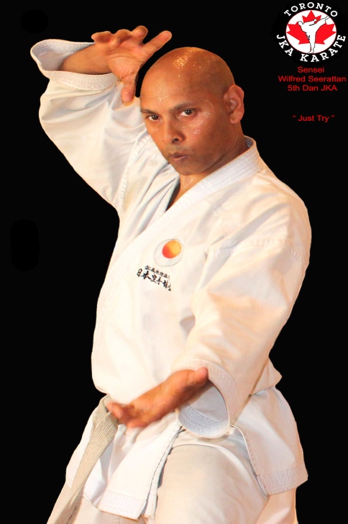of Toronto Shotokan Karate

**WHERE:** Rockwood JKA Dojo, 115 Main St. Rockwood 519-826-6111

**WHEN:** Sunday September 15th, 11-1pm, *kyu grading to follow

**COST:** $20/person * Students are encouraged to come dressed in Dogi due to space limitations

***Sensei Wilfred has been…***

1. Competing for 35 years

2. on Canada Team and competed in Japan 2004

3. Training with some of the best instructors in the world; Tanaka, Nakayama, Enoeda, Okazaki, Suzuki and Saeki to name a few